## **Author:**

**Sainik Basu**

**Date : 24/01/2024**

**Github link:**

[**https://github.com/sainikbasu/PropertyProject**](https://github.com/sainikbasu/PropertyProject)

## **Business Process it Supports:**

**It makes purchasing easier and better for customers. Our platform has everything customers need in one place: real-time property prices, furnished type updates, suggestions for flats and locations, property owners, and expert advice. Stay informed, make smart decisions, and be a part of the purchasing property from property site. Property site is all about helping customers succeed in purchasing**.

## Access Controls:

**Every Customer user has access to the Property site.**

## **Code Units:**

**Custom Object’s:**

1. **Property**
2. **Property Owner**
3. **Property enquiry**

### Apex Class:

### PropertyDetais.cls

### Aura Components:

### ctrlf_MyMasterPropertyTab

### ctrlf_MyPropertyDetails

### ctrlf_MyPropertyPricing

### ctrlf_MyPropertyResult

### ctrlf_MyPropertyVideo

### ctrlf_PropertyFilter

### ctrlf_PropertyOwner

### ctrlf_propertyResult

### **Data Model Diagram**

### 

### Diagram Link :

### https://mindful-otter-rn2y0m-dev-ed.trailblaze.lightning.force.com/lightning/setup/SchemaBuilder/home

# Objects Information

|  |
| --- |
| Object Name API Name Field Label Field api name DATA TYPE  **Property Property__c**  **Additional Room** **Additional_Room__c Picklist (Multi-Select)**  **Area Area__c Picklist**  **Available From Available_From__c Date**  **Carpet area(sqft) Carpet_area_sqft__c Number(7, 2)**  **Country Country__c Picklist**  **Electricity Status Electricity_Status__c Text(100)**  **Facing Facing__c Text(100)**  **Floor Floor__c Number(3, 0)**  **For Bachellor For_Bachellor__c Checkbox**  **For Family For_Family__c Checkbox**  **Furnished Type Furnished_Type__c Picklist**  **Furnishning Available Furnishning_Available__c Text Area(255)**  **Geo Map Geo_Map__c Geolocation**  **Landmark Landmark__c Text Area(255)**  **Location Location__c Text(255)**  **Maintainance Charge Maintainance_Charge__c Currency(6, 0)**  **No Of Balcony No_Of_Balcony__c Number(2, 0)**  **No Of Bath Room No_Of_Bath_Room__c Number(2, 0)**  **No Of Bed Room No_Of_Bed_Room__c Number(2, 0)**  **Property Description Property_Description__c Long Text Area(32768)**  **Property Main Image Property_Main_Image__c Rich Text Area(32768)**  **Property Owner Property_Owner__c Lookup(Property Owner)**  **Property Video URL Property_Video_URL__c URL(255)**  **Rent Rent__c Currency(8, 2)**  **Security Deposit Security_Deposit__c Currency(7, 0)**  **State State__c Picklist**  **Status Status__c Picklist**  **Street Street__c Text(150)**  **Verified Verified__c Checkbox**  **Water Availability Water_Availability__c Text(100)**  **Coverd area(sqft) Coverd_area_sqft__c Number(8, 2)** |

|  |
| --- |
| Object Name API Name Field Label Field api name DATA TYPE  **Property Owner Property_Owner__c Owner Address Owner_Address__c** **Text Area(255)**  **Owner Name**  **Owner_Name__c**  **Text(255)**    **Owner Phone**  **Owner_Phone__c**  **Phone**    **Owner Photo**  **Owner_Photo__c**  **Rich Text Area(32768)** |

|  |
| --- |
| Object Name API Name Field Label Field api name DATA TYPE **Property enquiry Property_enquiry__c Email Email__c Email**   **Message Message__c Long Text Area(32768)**    **Phone Phone__c Phone**    **Property Property__c** **Lookup(Property)** |

**Business Process Flow**: -

|  |  |  |
| --- | --- | --- |
| Number | Actor | Activity |
| 1 |  | START |
| 2 | Owner | Creates a property listing / gives the ad for sale or rent |
| 3 | Customer | Selects either purchase property or rent a property |
| 4 | Customer | Chooses location of the property |
| 5 | Customer | Selects Type of property (Furnished or not) |
| 6 | Customer | Checks availability date of property |
| 7 | Customer | Checks for floor of the property |
| 8 | Customer | Checks for the property facing details |
| 9 | Customer | Checks for Property Rooms (No of Bedrooms / Bathroom / Kitchen / Balcony etc) |
| 10 | Customer | Shares Contact Information (Email id or Phone number) with Owner |
| 11 | Owner | Contacts Customers for property sale / rent and closes deal |
| 12 |  | END |

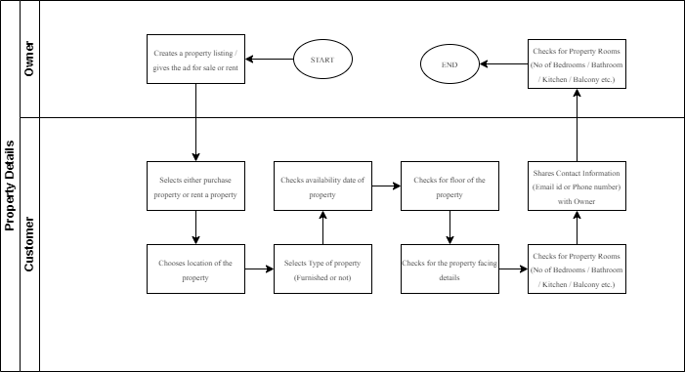

**Screenshot:**  
